PRODUCT SPECIFICATION
產品規格書

Customer Code 客戶代碼：
Customer Model 客戶型号：
Product Type 產品類型：Li-POLYMER
Model 型號：iPX
Material code 物料号：

Manufacturer  製造商 | Prepared by RD | Approved by RD |  | Approved by TD | Approved by QA | Approved by SALES
Customer  Approval  客戶確認 | Checked/date  審核/日期 |  | Approved/date  批准/日期

Add: No. 370, Yangxin Road, Dalang Town, Dongguan City, Guangdong Province, China.  Tel: +8613510942526  Fax:+86-0769-8200960 | 地址：廣東省東莞市大朗鎮楊新路 370 號  電話：+86-13510942526  傳真：+86-0769-82009960

AMENDMENT RECORDS
修改記錄
Revision  版本號 | Description  描述 | Originator  制定者 | Date  日期
A/0 | 首次發行 | Mark | 2024-8-2

Contents 目錄
1 Scope 適用範圍 4
2 Model 型號：iPX 4
3 Battery Specification 電池组規格 4
4 Battery Performances Criterion 電池性能標準 4
4.1 Visual Inspection外觀 4
4.2 Measurement Apparatus 測試設備 4
4.3 Standard Environmental Test Condition標準測試環境條件 5
4.4 Electrical Characteristics 電性能 5
4.5 Safety Performance安全性能 5
5 Shipment 運輸 5
6 Storage and Others 存放和其他 6
6.1 Long Time Storage 長期存放 6
6.2 Others 其他 6
7 Package and Marking包裝與標誌 6
7.1 Package 包裝 6
7.2 Marking 標誌 6
8 Cell drawing圖紙 6
9 Protection Circuit Mainboard (PCM) 保護板 7
9.1 PCM Parameter 保護板参数 7
9.2 電气线路图 7
10 Appendix 附錄 7
10.1 Instructions and Safety Requirement 使用說明和安全規程 7
10.2 Quality Evaluation 品質評定 9
10.3 Environment Protection 環保要求 9
10.4 Others 其他事項 9

1 Scope 适用范围
This document describes the Product Specification of the Lithium-ion Polymer (LIP) rechargeable battery supplied by Dongguan Saibili Technology Co., Ltd.
本檔描述的產品是由東莞市赛比利科技有限公司提供的鋰離子聚合物電池。

2 Model 型號：iPX

3 Battery Specification 電池組規格
No. | Items  項目 | Specifications  規格
3.1 | Charge Cut-off Voltage  充電截止電壓 | 4.35V
3.2 | Nominal Voltage  標稱電壓 | 3.81V
3.3 | Discharge Cut-off Voltage  放電截止電壓 | 3.2V
3.4 | Nominal Capacity  额定容量 | 2716mAh with 0.2C_{min} Discharge. Discharge,Defective rate is less than 0.3%  0.2C放電容量2716mAh. 放电容量不良率不超过千分之三
3.6 | Standard Charge Method  標準充電方法（25±3℃） | 0.2C charge to 4.35V,then CV charge till the charge current decline to 0.02C  0.2C恒流充電到4.35然後4.35V恒壓充電至電流減少到0.02C
3.7 | Standard Charge Time  標準充電時間（25±3℃） | 3 Hours（For Ref.）  3.0小時（供參考）
3.8 | Charge Method  充電方式 | Temperature  溫度 | Charge method  充電方式
3.8 | Charge Method  充電方式 | 0℃-15℃ | 0.2C_{min} Max (CC+CV, CV to 0.02C)
3.8 | Charge Method  充電方式 | 15℃-25℃ | 0.5C_{min} Max(CC+CV, CV to 0.02C)
3.8 | Charge Method  充電方式 | 25℃-45℃ | 0.5C_{min} Max(CC+CV, CV to 0.02C)
3.10 | Max Discharge Current  最大放電電流 | 0.5C_{min}
3.11 | Operating Temperature  操作溫度視窗 | Charge充電： 0℃-45℃  Discharge放電： -20℃-60℃
3.12 | Storage Temperature  儲存溫度  Storage Voltage 3.6-3.9V  儲存電壓3.6-3.9V | Less than 1 month : -20°C ~ 60°C  小於1個月： -20°C ~ 60°C  Less than 3 month : -20°C ~ 45°C  小於3個月： -20°C ~ 45°C  Less than 12month : -20°C ~ 25°C  小於12個月： -20°C ~ 25°C
3.13 | Battery Voltage For Shipment  電池出貨電壓 | 3.7-4.00V
3.14 | Battery Weight  電池重量 | Approx44.0g（Only For Ref.）  约44.0g 僅供參考
3.15 | Battery Inp  电池內阻 | ≤120mΩ（AC 1KHz）

4 Battery Performances Criterion 電池組性能標準

4.1 Visual Inspection外觀
There shall be no such defects as scratch, flaw, crack, rust, leakage, which may adversely affect the commercial value of battery.
電池外表面無刮痕，瑕疵，裂紋，電解液洩漏等能影響電池常規性能的缺陷。

4.2 Measurement Apparatus 測試設備

4.2.1 Dimension Measuring Instrument 尺寸測量設備
The dimension measurement shall be implemented by instruments with a precision no smaller than 0.01mm.
測量尺寸的儀器的精度應不小於0.01mm。

4.2.2 Voltmeter 電壓表
Standard class specified in the national standard or more sensitive class with inner impedance no smaller than 10 KΩ/V.
國家標準或更靈敏等級，內阻不小於10 KΩ/V。

4.2.3 Ammeter 電流錶
Standard class specified in the national standard or more sensitive class. Total external resistance including ammeter and wire shall be smaller than 0.01Ω.
國家標準或更靈敏等級，外部總體內阻包括電流錶和導線應小於0.01Ω。

4.2.4 Impedance Meter 內阻測試儀
Impedance shall be measured by a sinusoidal alternating current method (AC 1kHz LCR meter).
內阻測試儀測試方法為交流阻抗法(AC 1kHz LCR)。

4.3 Standard Environmental Test Condition標準測試環境條件
Unless otherwise specified，all tests stated in this Product Specification are conducted at blew condition
Temperature : 25±3℃, Relative humidity : 65±20%, Atmosphere pressure: 86~106Kpa.
除非有其他規格說明，所有測試都遵循以下規格：
溫度：25±3℃，相對濕度：65±20%，大氣壓強：86~106 Kpa。

4.4 Electrical Characteristics 電性能
No. | Items  項目 | Test Method and Condition  測試方法和條件 | Criteria  標準
4.4.1 | Minimum Rated  Capacity  最小倍率容量 | The capacity means the discharge capacity of the cell, which is measured with discharge current of 0.2C_{min} to cut-off voltage after the standard charge.  電芯放電容量，即標準充電後以0.2C_{min}恒流放電，到放电截止電壓時放出的容量 | 2716mAh
4.4.2 | Self-discharge  自放電 | After the charging specified in the Detailed Specifications, storied the cells for 28days, then measured the capacity with 0.2C_{min} till 2.75V  按規格書完全充電後，將電芯存放28天后，測試0.2C_{min}放電至2.75V的容量。 | Residual capacity＞90%  殘留容量＞90%
4.4.3 | Initial Impedance  初始阻抗 | Internal resistance measured at AC 1KHz after 50% charge  半充後在AC 1KHz條件下測試電芯交流內阻 | ≤60mΩ（Cell only）  ≤60mΩ單體電芯
4.4.4 | Cycle Life  迴圈壽命 | Test condition 測試條件：25±3℃  Step1: Charged the cell at 0.2C(CC+CV);  第1步:0.2C充電  Step 2: Standby 10min;  第2步:靜置10分鐘  Step3: Discharge the cell at 0.2C to 3.0V;  第3步:0.2C放電至3.0V,  Step 4: Standby 10min;  第4步: 靜置10分鐘  Step5: Repeat step1 to step 4 for 300 times.  Measure the capacity at the 300th cycle.  第5步:重複第1步至第4步300次，記錄300次迴圈後的容量。 | Capacity retention≥ 80% of initial capacity;  容量保持率≥80% of C_{min}

4.5 Safety Performance安全性能
No. | Items  項目 | Test Method and Condition  測試方法和條件 | Criteria  標準
4.5.1 | Short Circuit Test  外部短路試驗 | Cell short connected with resistance for 80±20 mΩ copper wires at room temperature.  室溫下將電芯正負極用電阻為80±20mΩ的銅線短接 | No explode, no fire  不爆炸，不起火
4.5.2 | Forced discharge test  過放測試 | With 0.5C constant discharge to cut-off voltage of 3.0V，The Cell reverse connect，with 1C constant-current charging 90 min.  電芯進行0.5C完全放電後反接，1C恒流充電90min | No explode, no fire  不爆炸，不起火
4.5.3 | Low Pressure (Altitude  Simulation) test  低壓測試 | Under the 20±3℃, the cell in the atmospheric pressure of 11.6 Kpa or lower vacuum environment stored for at least 6 h  在20±3℃下，將電芯在大氣壓為11.6Kpa或更低的真空環境中儲存至少6h | No explode, no fire  不爆炸，不起火
4.5.4 | Vibration Test  振動測試 | Cell (as of shipment) vibrated for 90 minutes for each of the three mutually perpendicular planes with total excursion of 1.15mm and with frequency of 10 Hz to 55 Hz  電芯(出貨)在三個相互垂直方向以1.15mm振幅,頻率為10~55Hz振動90分鐘. | No explode, no fire，no leakage  不爆炸，不起火，不漏液
4.5.5 | Shock test  衝擊測試 | Samples subjected to a half-sine shock of peak acceleration of 150gn, and pulse duration of 6 milliseconds. Each samples shall be subjected to three shocks in the positive direction followed by three shocks in the negative direction of three mutually perpendicular mounting positions for a total of 18 shocks.  每個電芯須經受最大加速度150gn和脈衝持續時間3毫秒的半正弦波衝擊。每個電池或電池組須在三個互相垂直的電池或電池組安裝方位的正方向經受三次衝擊，接著在反方向經受三次衝擊，總共經受18次衝擊。 | No explode, no fire，no leakage  不爆炸，不起火，不漏液

5 Shipment 運輸
The battery should be packed in cartons under the condition of half capacity (40~70% state of charge) for shipment. During the transportation, the batteries shall neither be exposed in the sun nor rain, and the violent vibration, impaction or squeezing shall be avoided too. The batteries shall be shipped by normal transportation such as by road, by train, by ocean or by air.
電池應在半荷電狀態（40~70%充電狀態）下包裝成箱進行運輸。在運輸過程中應防止劇烈振動、衝擊或擠壓，防止日曬雨淋，應適用汽車、火車、輪船、飛機等普通運輸工具。

6 Storage and Others 存放和其他

6.1 Long Time Storage 長期存放
The cell shall be stored at the temperature and the humidity condition specified in the detailed specification at all times. The voltage for the long time storage shall be in the range of 3.6~3.9V.
電芯應該在規格書規定的溫度和濕度條件下儲存，長期儲存時電芯電壓應該在3.6~3.9V的範圍內。

6.2 Others 其他
Any matters that this specification does not cover should be conferred between customer and MXZ。The warranty of product specification is 12 month from the day of cell manufactured.
任何此規格書沒有涉及的事項都應由客戶和牧行者協商確定。產品規格書自製造之日起12個月內有效。

7 Package and Marking包裝與標誌

7.1 Package 包裝
The product name, type, quantity, gross weight, manufacturer and contact address, shipping date shall be marked on the surface of the package, the mark such as "Up", "Don't be wet", "Put down lightly" shall also be included. Furthermore, the marking of the shipping package shall accord with the GB-191-2000 regulation.
包裝箱外應標明產品名稱、型號、數量、毛重、製造廠商及聯絡地址、出廠日期，還應有“向上”、 “怕濕”、“小心輕放”等必要標誌；其包裝儲運的標誌應符合GB-191-2000的規定。

7.2 Marking 標誌
Every battery shall have the following Chinese characters: product name，type，nominal voltage, nominal capacity, warning, produce date, lot number, manufacturer (or the marks of the above characters).
每個電池上應有下列中文標誌：產品名稱、型號、標稱電壓、標稱容量、警示說明、以及製造日期、批號、製造廠名、（或包括以上資料的串號）。
8 Cell drawing圖紙
（all unit in mm，not in scale 所有單位為mm，不按比例）
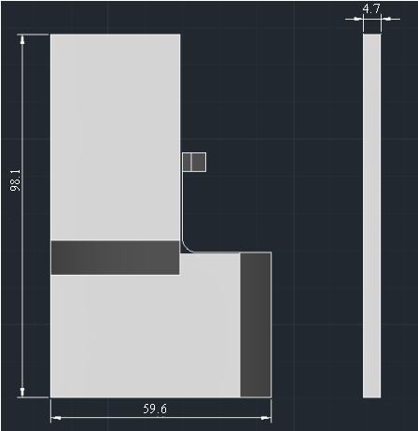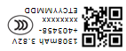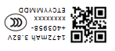
Items  項目 | Description  描述 | Specifications  規格（mm）
T | Thickness Before Shipping / 出貨厚度 | 4.7 Max
W | Width / 寬度 | 59.6 Max
L | Length / 長度 | 98.1 Max
M | FPC Length / 排线长度 | 以实际为准
N | Connector Width / 连接器寬度 | 以实际为准
A | Connector Length / 连接器长度 | 以实际为准

9 Protection Circuit Mainboard (PCM) 保護板

9.1 PCM Parameter保護板参数
No | 項目/Item | 條件/Condition | 規格/Specification
1 | 充電電壓/input Voltage | 輸入電壓/input Voltage | 4.4V
2 | 過充電  Overcharge | 保護電壓/Detection voltage | 4.425±0.025V
3 | 過充電  Overcharge | 恢復電壓// Release voltage | 4.225±0.050V
4 | 過充電  Overcharge | 保護延時時間Detection delay time | 36-144mS
5 | 過放電  Over discharge | 保護電壓/Detection voltage | 2.53±0.075V
6 | 過放電  Over discharge | 恢復電壓/ Release voltage | 2.93±0.075V
7 | 過放電  Over discharge | 保護延時時間/ Detection delay time | 18-72mS
8 | 充/放電過流  Over discharge current | 放電過流保護電流/Over current | 4.0～10.0A
9 | 充/放電過流  Over discharge current | 放電過流保護延時/delay time | 10-20mS
10 | 短路保護  Short detection | 短路保護延時/ Short detection delay time | 50-300uS
11 | 短路保護  Short detection | 恢復條件/Release Conditions | 斷開負載/Cut off load
12 | 自耗電  Normal current consumption | 工作狀態下自耗電  Normal current consumption of PCM | Max 200uA跳动
13 | 工作条件  Working conditions | 最大持續充  Max charge/discharge current | 2.1A
14 | 內阻  IR resistance | PCM內阻/ IR of PCM | ≤90mΩ
9.2 電气线路图
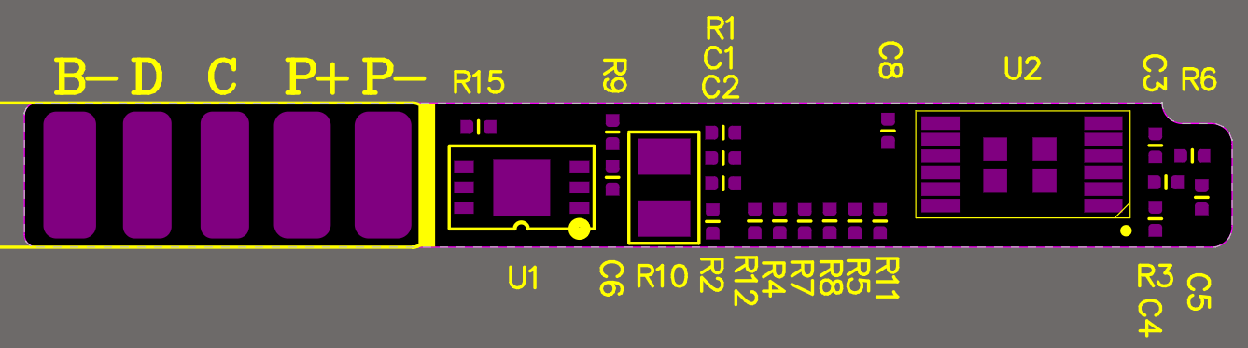
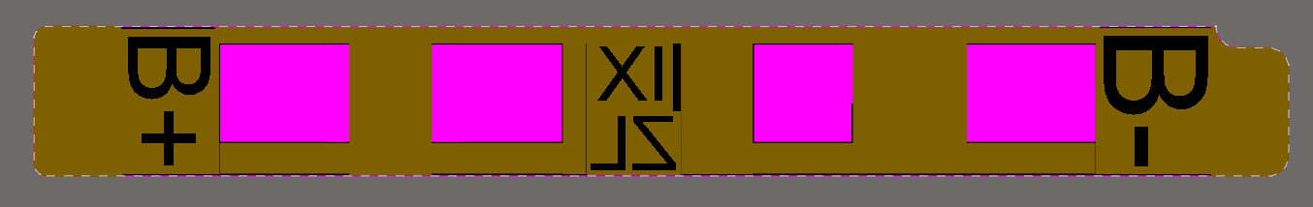
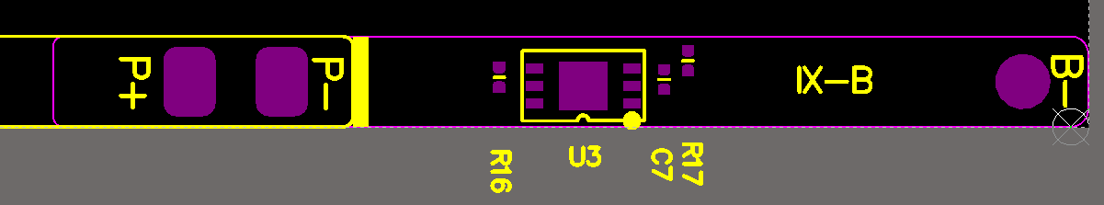
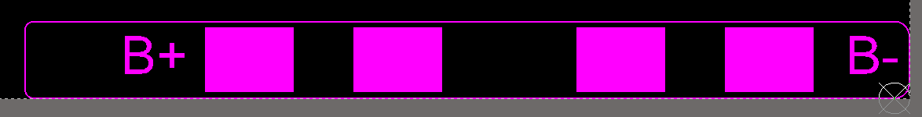
9.3 原理图
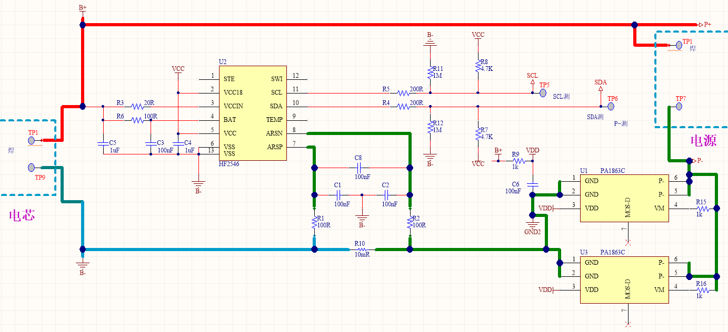

9.4 BOM清单
PCB |  |  | 1 | 兆龙
电芯 | 403458/403958 |  | 2 | 中颖
黑色高温胶
诺美纸
头盖
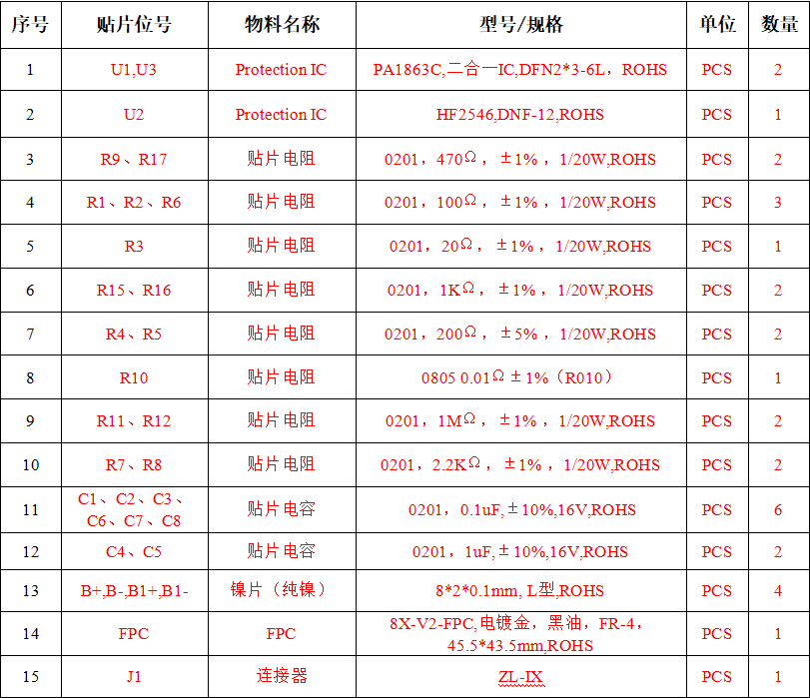
10 Appendix 附錄

10.1 Instructions and Safety Requirement 使用說明和安全規程
10.1.1 Recommending Usage推薦使用事項
10.1.1.1 Please read the battery instructions and the label on its surface before using.
使用電池前，請仔細閱讀使用說明書和電池表面標識。
10.1.1.2 Use the battery indoors under normal condition, temperature: 25±3℃, relative humidity: 65±20%.
請在正常的室內環境中使用電池，溫度：25±3℃，相對濕度：65±20%。
10.1.1.3 While using, the battery shall be kept away from heat, high voltage environment and avoided children’s touching. Do not drop the battery.
在使用過程中，應遠離熱源、高壓，避免兒童玩弄電池，切勿摔打電池。
10.1.1.4 Use the compatible charger. Do not put the battery into the charger more than 24hours.
本電池只能使用配套充電器充電，不要將電池放在充電器超過24小時。
10.1.1.5 Do not touch contacts together. Do not demolish or assembly the battery by yourself. Do not put the battery in the damp place so as to avoid danger.
切勿將電池正負極短路，切勿自己拆裝電池，也勿讓電池放在受潮處，以免發生危險。
10.1.1.6 When the battery was stored for a long time, put it well in its half capacity state. Do not wrap it with conduct material to avoid the damage caused by the direct contact between the metal and battery. Keep the battery in cool and dry place.
長期不用時，請將電池儲存完好，讓電池處於半荷電狀態。請用不導電材料包裹電池，以避免金屬直接接觸電池，造成電池損壞。將電池保存陰涼乾燥處。
10.1.1.7 Well disposed the disused battery. Do not put it into fire or water.
廢棄電池請安全妥當處理，不要投入火中或水中。

10.1.2 Hazard Warning危險警告
10.1.2.1 Forbid Disassemble Batteries 禁止拆裝電池
The battery has protective component and circuit internally to avoid danger. Improper disassembly will destroy its protective function and make it heat, smoke, distort or burn.
電池內部具有保護機構和保護電路可以避免發生危險。不合適的拆裝會損壞保護功能，將會造成讓電池發熱、冒煙、變形或燃燒。
10.1.2.2 Forbid Short-circuit Batteries 禁止讓電池短路
Do not touch the plus and minus contacts with metals. Do not put the battery with metal element together in either storage or movement. If the battery is short-circuit, it carries magnified current, which will cause damage and make the battery heat, smoke, distort or burn.
不要將電池的正負極用金屬連接，也不要將電池與金屬片放在一起存儲和移動。如果電池被短路，將會有超大電流流過，將會損壞電池，造成電池發熱、冒煙、變形或燃燒。
10.1.2.3 Forbid heat and burn the battery 嚴禁加熱和焚燒電池
Heating or burning the battery, it will cause the isolated element in the battery dissolved, protection function stopped or the electrode burned. Overheating will make the battery heat, smoke, distort or burn.
加熱和焚燒電池將會造成電池隔離物的溶化、安全功能喪失或電解質燃燒，過熱就會使電池發熱、冒煙、變形或燃燒。
10.1.2.4 To avoid use the battery near the heat 避免在熱源附近使用電池
Do not use the battery near the fire and stove, or over 80℃. Overheating will cause the battery internal short-circuit and make it heat, smoke, distort or burn.
不要在火源、烤爐附近或超過80℃的環境中使用電池，過熱將會導致電池內部短路，使電池發熱、冒煙、變形或燃燒。
10.1.2.5 Forbid bathing the battery 禁止弄濕電池
Do not dampen the battery, or even immerse it in the water, which will cause internal protection circuit and its function lost or abnormal chemical reactions, which will lead to heating, smoking, distortion or burning.
不要弄濕電池，更不能將電池投入水中，否則會造成電池內部保護電路和功能喪失及發生不正常的化學反應，電池有可能發熱、冒煙、變形或燃燒。
10.1.2.6 Avoid charging near fire or in the sunlight Otherwise, it will cause internal protection circuit and its function lost or abnormal chemical reactions, which will lead to heating, smoking, distortion or burning.
避免在火源附近或陽光直射下充電,否則會造成電池內部保護電路和功能喪失和發生不正常的化學反應，電池有可能發熱、冒煙、變形或燃燒。
10.1.2.7 Danger in using non-indicated chargers in 使用非專用充電器給電池充電，會發生危險
Charging in abnormal condition, the battery will cause internal protection circuit and its function lost or abnormal chemical reactions, which will lead to heating, smoking, distortion or burning.
在非正常的條件下充電會造成電池內部保護電路功能喪失和發生不正常的化學反應，電池有可能發熱、冒煙、變形或燃燒。
10.1.2.8 Forbid Damage Battery 禁止破壞電池
Do not damage the battery with the metals gouged, forged or dropped etc.，otherwise, it will cause the battery over-heated, distorted, smoked or burned, even in danger.
禁止用金屬鑿入電池、錘打或摔打電池或其他方法破壞電池，否則會造成電池發熱、冒煙、變形或燃燒，甚至會發生危險。
10.1.2.9 Forbid directly welding on the battery 禁止在電池主體上直接焊
Overheating will cause the isolated element dissolved in the battery and protective function lost, even will cause overheating, distortion, smoking or burning.
過熱將會造成電池隔離物的溶化、安全保護功能喪失，使電池發熱、冒煙、變形或燃燒。
10.1.2.10 Forbid directly charging on the power socket or car kit cigarette. High voltage and amplified current will damage the battery or will cause overheating, distortion, smoking or burning.
嚴禁將電池直接在電源插座上或車載點煙器上充電,高壓、大電流將會過電池而使其損壞，或使電池發熱、冒煙、變形或燃燒。
10.1.2.11 Do not use this battery for other equipment 不可將電池用於其他設備
Improper usage will damage the battery and reduce its cycle life, even will cause overheating, distortion, smoking or burning.
不恰當使用會損壞電池的性能、降低壽命，甚至會使電池發熱、冒煙、變形或燃燒。
10.1.2.12 Do not touch the leak-out battery 不要直接觸及漏液電池
The leak-out electrolyte will cause the skin uncomfortable. If it drops into eyes, do not rob the eyes but wash in time, and go to hospital for treatment.
滲漏的電解液會造成皮膚不適，萬一電解液進入眼睛，儘快用清水沖洗，不可揉眼，並迅速送醫院處理。

10.1.3 Warning 警告
10.1.3.1 This battery cannot mix with deposal or twice-recycled batteries in use. Otherwise, for its abnormal charge and discharge, it will cause overheating, distortion, smoking or burning.
電池不可與其他類型的一次或二次電池混用，否則因為不正常的充、放電造成電池發熱、冒煙、變形或燃燒。
10.1.3.2 Keep the battery out of children’s reach and prevent them biting or swallowing the battery.
將電池遠離孩童不能得到的地方，以避免孩童噬咬或吞咽電池，如果吞咽了電池，應迅速送醫院處理。
10.1.3.3 Do not insert the battery into the charger for a long time. If charging beyond the normal time, the battery is still in the charger, please stop charging. The abnormal charging will cause overheating, distortion, smoking or burning.
不要將電池放在充電器中太長時間。如果超過正常充電時間，並且充電器仍在充電，請停止充電。不正常的充電有可能會使電池發熱、冒煙變形或燃燒。
10.1.3.4 Do not put the battery into microwave oven or any other pressure apparatus. Take the battery away from the cellular phone or the charger if it is instant heated or leak-out (or odors), and then depose it. Using the bad battery will causes overheating, distortion, smoking or burning.
不可置於微波爐或其他壓力容器中，瞬間加熱或結構漏液（或有異味），應讓電池離開手機或充電器並棄用。使用不正常的電池會發熱、冒煙、變形或燃燒。

10.1.4 Cautions 注意事項
10.1.4.1 The battery shall be prevented to be exposed in effulgence so as not to cause over-heated, distort, smoke and weaken its performance and cycle life.
避免在強光爆曬環境下使用電池，以免發熱、變形、冒煙.至少避免電池性能下降、降低壽命。
10.1.4.2 Electro Static-free 防靜電
There is a protective circuit inside the battery to prevent contingency. Do not use the battery in the Electro static circumstances, (above 1000V), for it is easily destroyed the circuit board so that the battery doses not work and causes overheating, distortion, smoking or burning
電池中裝有保護電路以避免各種意外情況發生。不要在產生靜電的場所使用電池，因為靜電（1000V以上）容易損壞保護板，而導致電池工作不正常，發熱、變形、冒煙或起火燃燒。
10.1.4.3 Charging Temperature Range 充電溫度範圍
Recommended Charging temperature range is 25~45℃, beyond which it will weaken the electrochemical performance of the battery and also shorten its cycle life.
推薦的充電溫度範圍是25~45℃。在超出此範圍的環境中充電會造成電池性能下降、減少壽命。
10.1.4.4 Read carefully the manual before use or whenever in need.在使用電池之前，請仔細閱讀使用手冊並經常在需要時閱讀。
10.1.4.5 Charging Method 充電方式
Please use the special chargers with the recommended charging method to charge the battery.
請使用專用充電器和推薦的充電方式，在推薦的環境條件下給電池充電。
10.1.4.6 First Usage 第一次使用
When you use the battery for its first time, do not put it into the cellular phone or any other equipment once you find it in unusual conditions such as unclearness or odors. The battery should be returned to the vendor.
在第一次使用電池時，若發現電池不整潔或有異味等不正常現象，不可繼續將電池用於手機或其他它設備，應將電池返回銷售商。
10.1.4.7 Children Use 兒童使用
When Children use the battery, they should be under their parents’ instructions and superintend in use.
兒童使用電池前，應受父母指導，並在使用中受監督是否正確。
10.1.4.8 Avoid Children’s Touch 避免孩童接觸電池
Battery should keep out of the place where children in reach. Prevent children taking the battery out of the charger or the cellular phone to play.
電池應放在孩童不易拿到的位置，應避免孩童將電池從充電器或手機中取出、玩弄。
10.1.4.9 To avoid the leak-out liquid be exposed to the skin or clothes. If touched, please wash by clean water so as not to cause the skin uncomfortable.
注意避免電池漏液接觸皮膚或衣物，若已接觸請用清水沖洗，以免造成皮膚不適。
10.1.4.10 When you buy the battery, please note how to contact with the vendors, so that you may get in touch with vendors for consultation whenever in need.
購買電池時，請注意銷售商聯絡方法，以便需要時及進與銷售商取得聯繫，得到諮詢。
10.1.4.11 Safety Usage Guarantee 安全使用保障
If the battery is used on other instruments, please contact with your manufacturer for how to get the best performance, at least consult its maximum current, fast charge and special application.
如果將電池用於其他設備，請與供應商討保護功能的完善性。至少應該諮詢電池的大電流、快速充電、特殊應用的問題。

10.2 Quality Evaluation 品質評定
Quality evaluation composes of authoritative check and quality consistence check. Authoritative check is carried out on design decision, emended design and production decision. It should be confirmed by both Purchaser and Vendor on sampling proposal, check project, sequence and judgment etc., which in principle should be all included. Quality consistence check should be divided into lot by lot check-up and periodical check-up so as to test the quality steadiness during the products in production (refer to GB2828-1987 standard). The detailed check-ups compose of appearance, internal resistance, rating capacity or 1C5A discharging capacity etc.
品質檢驗分為鑒定核對和品質一致性檢驗。鑒定檢驗一般在設計定型、更改設計和生產定型時進行，抽樣方案、檢驗專案、順序以及判定規則等事宜由供需雙方協商確定。原則上應包括以上各項性能試驗。品質一致性檢驗分為逐批檢查和週期檢查，用以判定產品生產過程中能否合格保證產品品質的持續穩定。可以參照GB2828-1987，標準執行。具體檢查的檢驗項目應包括外觀、內阻、額定容量或放電容量等。

10.3 Environment Protection 環保要求
This product accords with ROHS requirement.
此產品符合ROHS環保要求。

10.4 Others 其他事項
All the above are the agreed the battery descriptions and test regulation between Purchaser and Vendor. It can be carried out if there is no any new written agreement or modification notice occurred.
以上述，可以作為供需雙方對於電池產品性能和檢驗規則的約定框架。如果沒有新的書面約定或更改通知，即可按此執行。

附件1：电池丝印图

